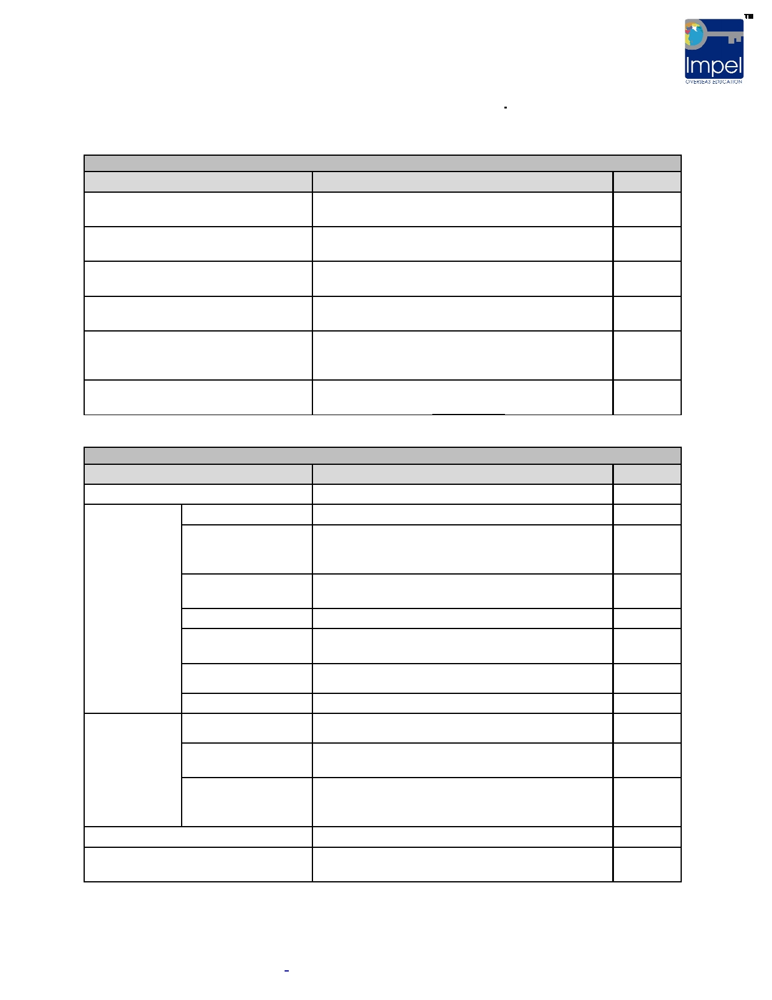

**Document Checklist for USA Visa**

**Please ensure you carry all the documents in the below mentioned order.**

**SET I**

Passport

**Document Required**

**Document Description**

Passport should be valid for at least 6 months

more than the duration of the program

I-20 sent by the university. Sign the I-20 before

**Yes / No**

Original I-20 form

Visa Fee Receipt issued at HDFC

Bank

DS-160 submission confirmation page

Visa Interview Appointment Letter

SEVIS Fee Receipt

your visa interview

This receipt is valid for 1 year from the date it is

generated

Print out of the confirmation page generated after

submitting DS-160 form

Print out of the Visa Interview Appointment Page.

This page is generated after scheduling the interview.

Print out of confirmation page generated after

paying SEVIS Fee Online

**SET II - Financial Documents**

**Document Required**  **Document Description**  **Yes / No**

CA Certificate

Liquid Funds -

Source of

Funds for 1

year tuition fee

and living

costs

Annual

Income -

Proof to show financial status

of the

sponsor(s)

Education Loan

Savings Account

Fixed Deposits

PF

Life Insurance

National Savings

Certificates

Shares

Income from

Employment

Income from Rent

Income from

Agriculture

Refer Sample CA Certificate

Letter from Bank

Transactions for the past 6 months and Bank Letter

/ Bank Passbook showing transactions of last 6

months

FD Receipts showing the maturity amount and

maturity date

PF Statement from Employer / PF Office

Letter from Insurance agency mentioning the

surrender value

Original Certificates

Surrender Value Certificate

Salary Slip from employer, Last 3 years IT Returns Rental Agreement, Proof of ownership of property

given for rent

Valuation Report taken from the MRO, Proof of

ownership of agriculture land which is the source of

income

Affidavit of Support from Sponsor

Affidavit of Support

Refer Sample Affidavit of Support

Required if funds shown are on the name of the

student.

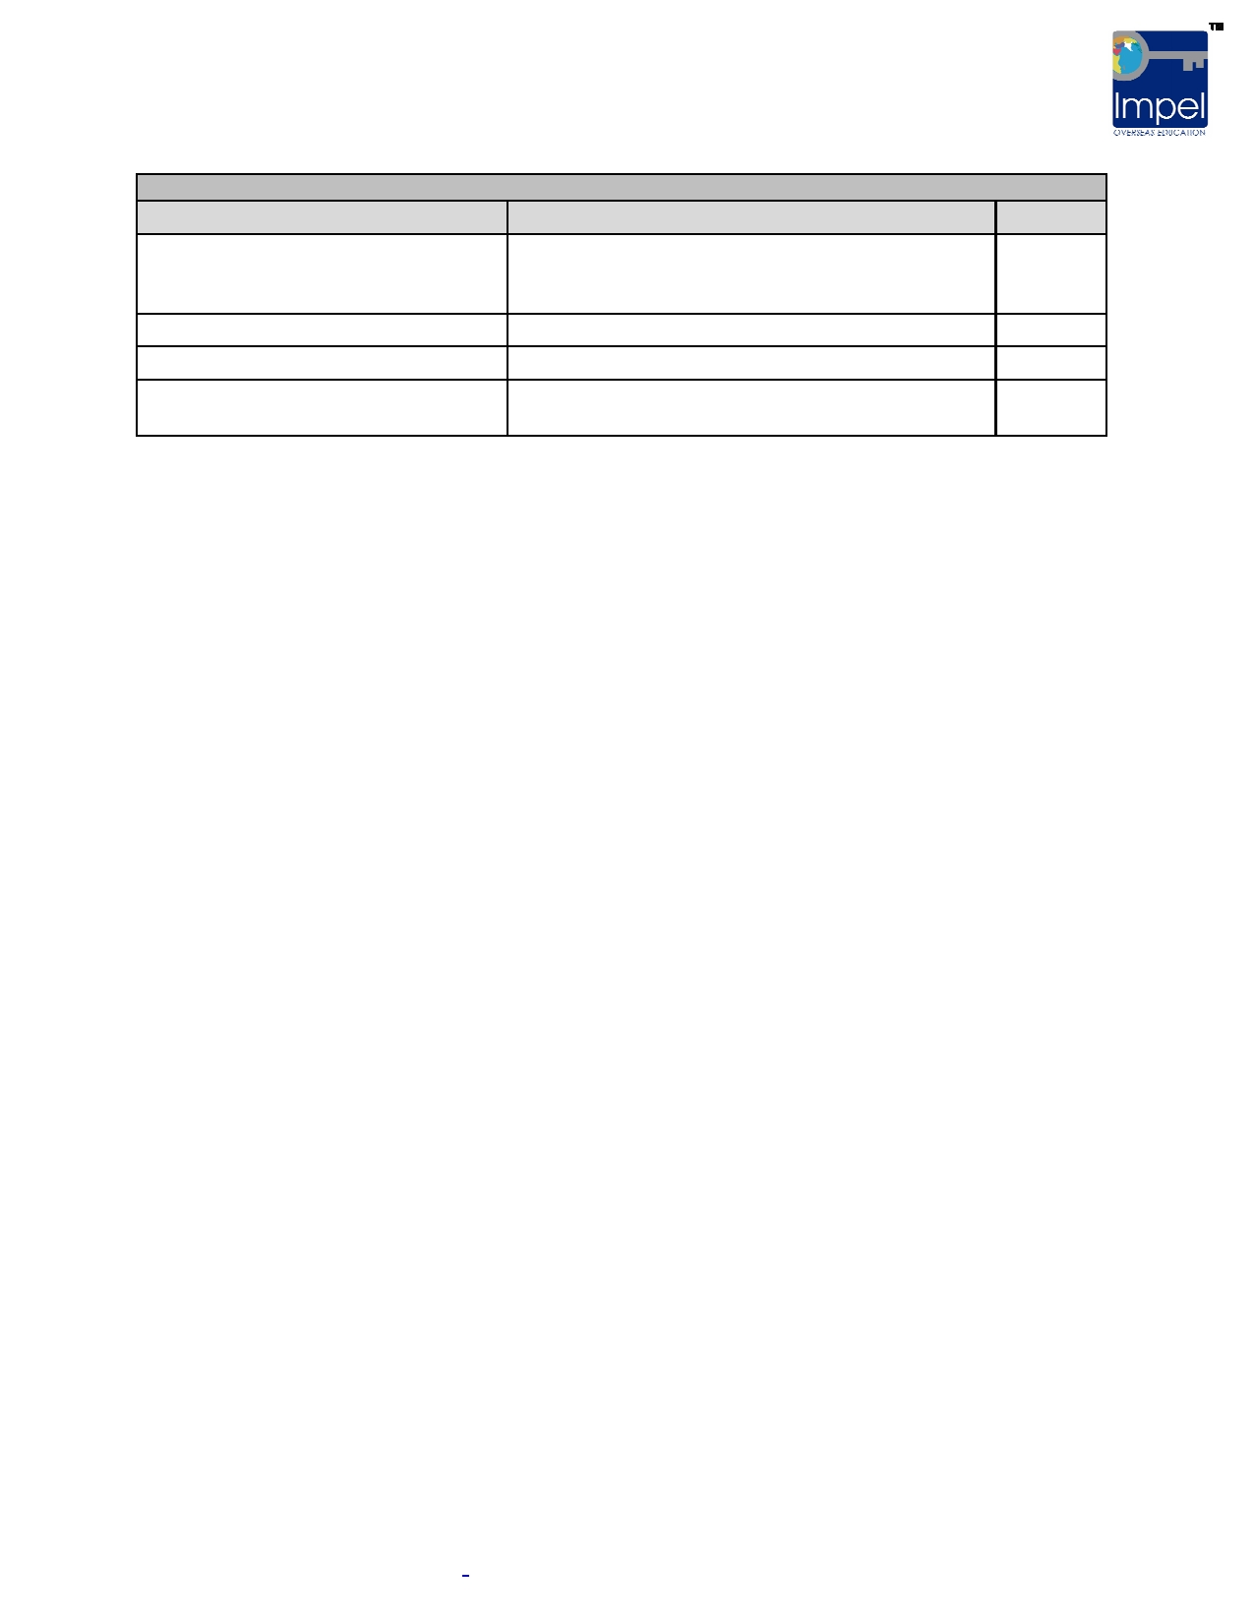

Degree

**Document Required**

**SET III - Academic Documents**

**Document Description**

Originals of all Degree Transcripts, Degree

Certificate / Provisional Certificate / Course

Completion Certificate

**Yes / No**

12th Class 10th Class

Score Reports

Original 12th Class Certificate Original 10th Class Certificate

Original Score Reports of all tests taken (SAT /

GRE / GMAT, TOEFL / IELTS)

**Documents to be submitted in VFS Office if Visa Interview is at Mumbai Consulate**

• Copy of first and last 2 pages of the passport

• Print out of DS-160 submission Confirmation page

• Embassy Copy of HDFC Bank Receipt

• Visa Interview Appointment Letter

• Copy of I-20

• Print out of SEVIS Fee Receipt

**Please note:** These documents have to submitted at the VFS Office in (Mumbai / Pune / Ahmedabad) at

least 3 working days before the Visa Interview Date (Check with Impel to find the list of VFS, USA Consulate Holidays and plan when to submit your documents).



**Sample Format - Chartered Accountant Certificate**

To be obtained on the letterhead of the CA

I, Mr/Ms. _ _ _ _ _ _ _ _ _ _ _ _ _ _ _ _ _ fellow member of the Institute of Chartered

Accountants of India, have reviewed the financial condition of Mr/Ms. _ _ _ _ _ _ _ _ _ _ to pay the educational costs at the _ _ _ _ _ _ _ _ _ _ _ _ _ _ _ _ _ _ _ _ place _ _ _ _ _ _ _ _ _ _ _ _

_ _ _ _ _ U.S.A. which have been estimated at US $ _ _ _ _ _ _ _

**Source of Fund**

a.) Scholarships

b.) Savings in India

i.) Cash Assets

ii.) Immovable Assets

c.) Savings Abroad

d.) Income from India

e.) Loans

f.) Other Sources

**Indian Rupees**

xxx

xxx

xxx

xxx xxx xxx xxx

____

XXX

**Equivalent $**

xxx

xxx

xxx

xxx xxx xxx xxx

____

XXX

**Notes:**

1. The amount is rounded off to the nearest units.

2. Exchange rate of Rs. __/- per US $ adopted

3. The applicant is sponsored by his/her parents.

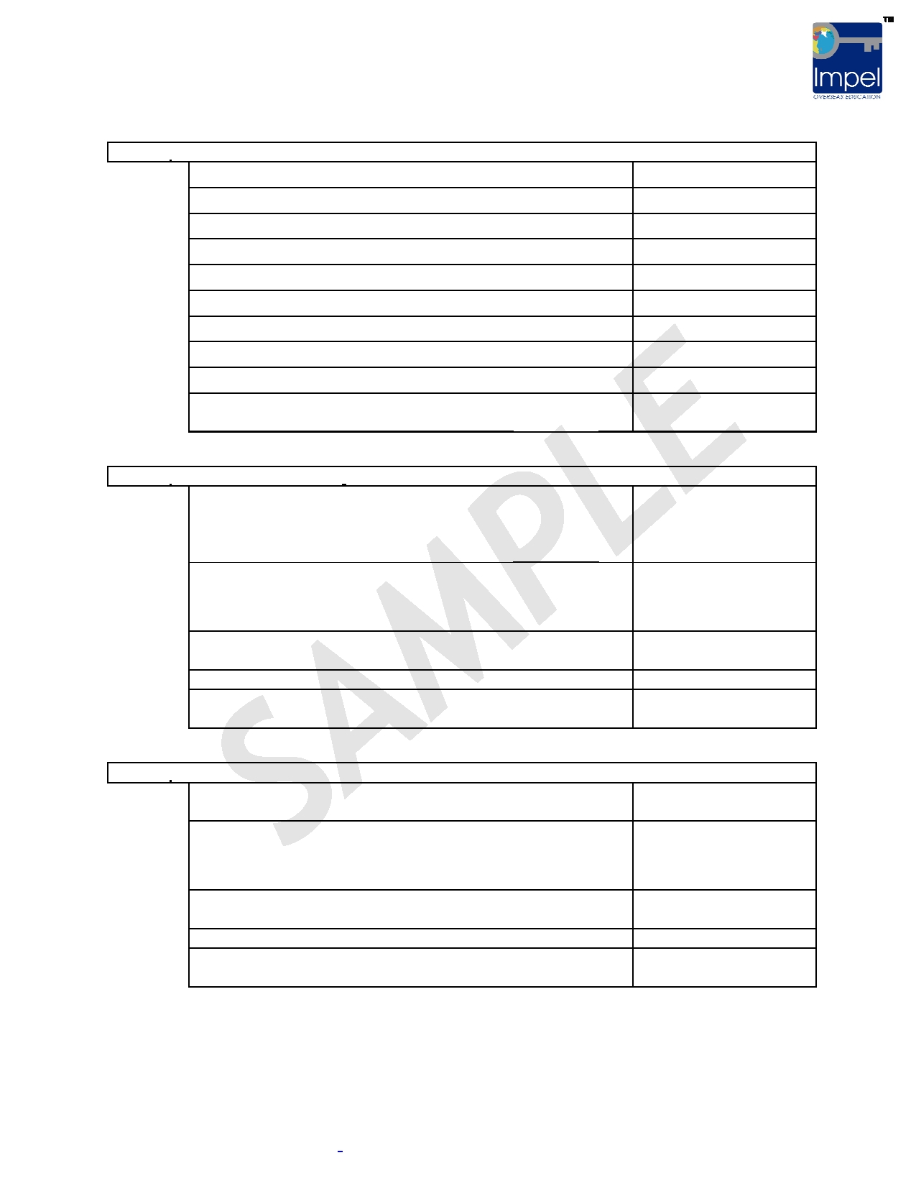

**Annexure:**

**a.) MOVABLE ASSETS:**

National Savings Scheme A/c no_______

Unit Trust Certificates ____ No. _______

UTI - Monthly Income Scheme

Master Equity Plan

Master Gain

LIC Policies -Surrender value

Furniture & Jewelry

Vehicles (Evaluator certificate)

All other Shares & Debentures (@ present market value)

xxx

xxx xxx xxx xxx xxx xxx xxx xxx

**TOTAL ____**

**XXX**

**b.) IMMOVABLE ASSETS:**

Residential property at _________ (address) measuring

_____________ Sq. ft.

Site area and built area__________ Sq. ft., as valued by

(name of the Govt. evaluator) report dated _________

Immovable residential site No. __________ located in

Survey No. _________ in _____ (address), measuring east to west.

xxx

xxx

Immovable agricultural land located at ______(address) as xxx

valued by ____________ (Name of the evaluator).

Machinery (if any) xxx

**c.) BANK BALANCE:**

**TOTAL ____**

**XXX**

Savings Bank A/C No. ______ at __________ (Bank

Name, Branch, City)

Current Bank A/C No. ______ at __________ (Bank

Name, Branch, City)

Fixed Deposit A/C No. ______ at __________ (Bank

Name, Branch, City)

Other Accounts

xxx

xxx

xxx

xxx

**TOTAL ____**

**XXX**

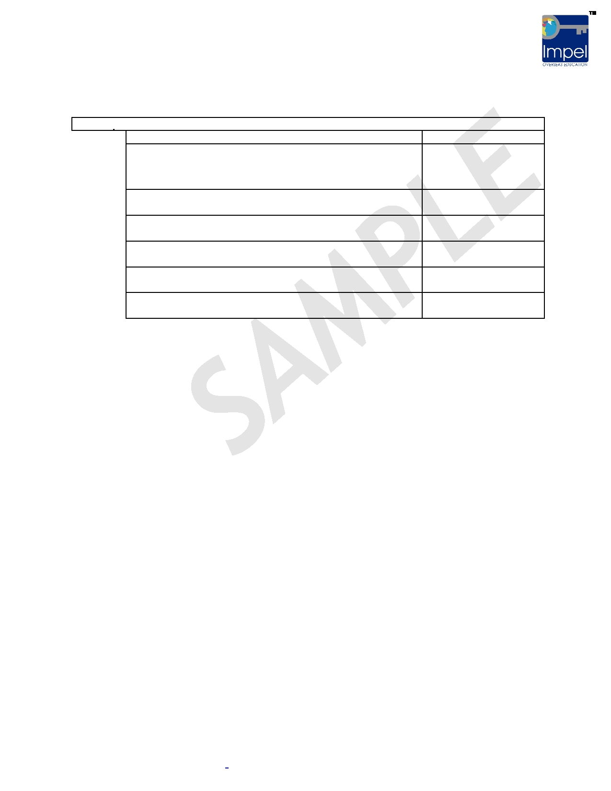

**d.) ACCOUNT INCOME:**

Salaries (include salary certificate or pay-slips)

Rents from Houses or shops etc. (include Rent declaration

certificate)

Income from Agricultural land (include Income certificate

issued by M.R.O)

Interest from all shares and debentures (all original

Certificates)

xxx

xxx

xxx

xxx

**TOTAL ____**

**XXX**

**GRAND TOTAL ____**

**XXX**

**EQUIVALENT TO US $ ____**

**XXX**

Place: Signature:

Printed Name:

Date: Regd. No:



**Sample Format - Bank Certificate**

**TO WHOMSOEVER IT MAY CONCERN**

This is to certify that Mr. / Mrs. XXXXXXX is maintaining a Savings Bank Account with us since ______, bearing A/c No. XXXX and the balance in the said Account on (dd-mm-yyyy) is Rs. XXXX (Rupees in words) which is equivalent to US $ (amount). The rate for One US Dollar is taken as Rs. ____.

This Certificate is issued on the specific request of the account holder without any obligation and liabilities to the Bank or any of its officers.

Seal & Signature of the Bank Manager

**Notes:**

1. Only one original to be obtained for visa purpose.

2. After the Bank Certificate is obtained, the same amount has to be reflected in the AOS

and CA Certificates (without any discrepancy)

3. Name and address of the branch, with contact details such as Phone no. and email (if

available) have to be included in this Bank Certificate.



**Sample Format - Affidavit of Support**

To be obtained from sponsors on Rs.10 non-judicial stamp paper

**Affidavit of Support**

We, Mr. XXXX (Father's name) s/o Mr. XXXX (Grandfather's name), Deponent 1, and Mrs. XXXX (Mother's name) w/o Mr. XXXX, Deponent 2, residents of ________ (city), do hereby

solemnly affirm & state that:

1. That our son/daughter ____________is approaching your esteemed consular office for

Student Visa. He/She has been granted admission by _______________ (University name) to do his/her ____ (name of the program). He / She has completed his Bachelor's in __________ and has work experience of __ years in ______as _________.

2. That Deponent 1 is working as _________ in _________________ and Deponent 2 is

working as ___________________in ____________________

Our property details are as below:

**Properties in the name of Deponent 1:**

a) Details of property with values to be given

b) xxx c) xxx

**Properties in the name of Deponent 2:**

a) xxx b) xxx c) xxx

3. That we are getting an annual income of Rs.___________, which is equivalent to U.S $

________ from the above mentioned sources. We have been saving substantial _

amounts from our incomes to provide for our son's / daughter's further education plans. Now we have collected the amount that we have invested in various financial schemes and deposited the same in our account, for use of our son / daughter.

4. From our balance savings, annual income and other sources as specified above, we will

provide for his / her education and living expenses.

5. That our son / daughter is proceeding to study in the U.S.A with the sole aim of having

higher education and leave U.S.A to pursue his / her career.

6. That through this Affidavit, we undertake to support our son financially till the completion

of his education in the U.S.A.

7. We assure that our son / daughter will not face any financial problems during his / her



stay in U.S.A and that he / she will not be a Public Charge on the Government of U.S.A.

8. That we request you to grant his / her F-1 visa to facilitate his / her higher education in

the U.S.A.

DEPONENT 1

DEPONENT 2

Solemnly affirmed and signed before me on this the

_________ (Place)

Witness:

1. xxx

2. xxx

____ day of _______ (month), 2010, at